

ITERATION 2

DOCUMENTATION

**Introduction** **3**

**Iteration 1 Feedback** **4**

**Use Case Diagram** **5**

**Activity Diagrams** **30**

**Latest Entity Relation Diagram** **34**

**User Interface Design** **35**

**Sample Reports** **41**

**Standards and Best Practice** **44**

**Conclusion** **45**

# Introduction

Having a better understanding to what the main user wants and what the main users do, we have a better understanding to what the user needs and how we implement their requirements.

In this documentation we will be showing how our users will interact with the system, and updated ERD, the BETA vision the user will see of the system’s frontend, sample reports of a specified query, and what is expected to come for the forthcoming iterations.

# 

# Iteration 1 Feedback

**Judging session reflection:**

The overview of the judging was gladly more positive than negative. Although the negatives were hard to take in, they were entirely understandable for the group and made us go back to the drawing board. The judges openly and easily understood what the project is about after their questionnaire. Their questions and responses were honest and thankfully ruthless for us to improve our project’s overview.

**Things that went right during our judging session:**

Our presentation slides were well received, looked professional, and we mentioned all the topics that we prepared for. Although we could’ve elaborated on some topics, we were aware of the 10 minute time limit and we aimed to keep it straight to the point.

**Things that went wrong during our judging session:**

We were not prepared as much as we could have been. As a group one of our weaknesses is speaking/presenting.

**Things that could have been improved on:**

Properly explaining what was going on. Although we prepared beforehand by assigning who is talking about which part of the presented presentation and practicing as a group in empty classes, the “stage fright” got to some of us and made us a bit inconsistent.

**Positive and constructive feedback:**

We received feedback on our database as the judges were unable to understand it on first viewing. We were also advised to possibly increase the scope of the project as it may currently not be enough work for a group of 5 to do.

**Plan of action to address the feedback:**

One of the key advises the judges gave us was to expand the project’s scope. At first, it was going to be a simple Add/Update/Delete functional system with additional extras for the main stakeholder (Nelson Mandela Metropolitan Municipality Technical Department), but for a group of five members, we were advised to increase the scope with more features.

# Use Case Diagram

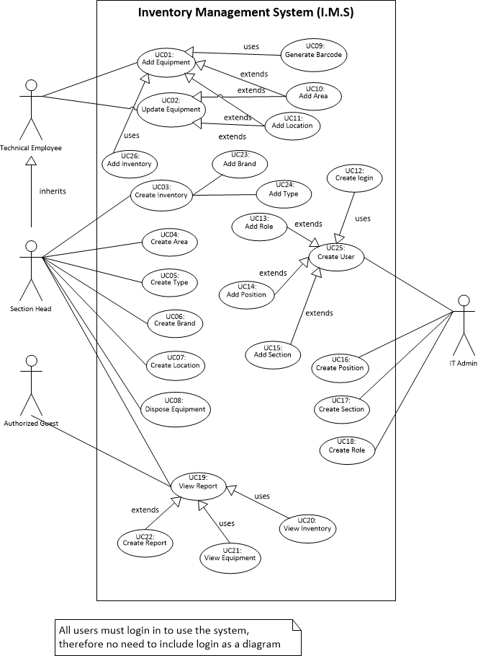

Author (s): Neerav Panchal Date: 03/05/2018

Version: 1

|  |  |  |  |
| --- | --- | --- | --- |
| USE CASE NAME: | Add Equipment | | USE CASE TYPE |
| USE CASE ID: | UC01 | | Business Requirements: □ |
| PRIORITY: |  | | System Analysis: ☑ |
| SOURCE: |  | | System Design: □ |
| PRIMARY BUSINESS ACTOR | Technical Employee, Section Head | | |
| PRIMARY SYSTEM ACTOR | Inventory Management System | | |
| OTHER PARTICIPATING ACTORS: |  | | |
| OTHER INTERESTED STAKEHOLDERS: |  | | |
| DESCRIPTION: | The user is able to add an equipment to specify that the equipment is in use. | | |
| PRE-CONDITION: |  | | |
| TRIGGER: | Add Equipment Buton | | |
| TYPICAL COURSE | Actor Action | System Response | |
| OF EVENTS: | 1. The user will generate a barcode and add it. | 2. The user enters the date of commission as well the date of purchase. The user selects the equipmen’s status. | |
| (Step by Step interaction) | 3. The user selects the equipment’s type of usage. | 4. The coordinates will get viewed and loaded. | |
|  | 5. Once all necessary fields has been entered, the equipment will get added. |  | |
|  |  |  | |
|  |  |  | |
|  |  |  | |
|  |  |  | |
|  |  |  | |
| ALTERNATE COURSES: | 1a. The user can type in manually. | | |
|  |  | | |
|  |  | | |
|  |  | | |
| CONCLUSION: |  | | |
| POST-CONDITION: |  | | |
| BUSINESS RULES |  | | |
| IMPLEMENTATION CONSTRAINTS AND SPECIFICATIONS |  | | |
| ASSUMPTIONS: |  | | |
| OPEN ISSUES: |  | | |
| TABLES USED: | EQUIPMENT | | |

Author (s): Neerav Panchal Date: 03/05/2018

Version: 1

|  |  |  |  |
| --- | --- | --- | --- |
| USE CASE NAME: | Update Equipment | | USE CASE TYPE |
| USE CASE ID: | UC02 | | Business Requirements: □ |
| PRIORITY: |  | | System Analysis: ☑ |
| SOURCE: |  | | System Design: □ |
| PRIMARY BUSINESS ACTOR | Technical Employee, Section Head | | |
| PRIMARY SYSTEM ACTOR | Inventory Management System | | |
| OTHER PARTICIPATING ACTORS: |  | | |
| OTHER INTERESTED STAKEHOLDERS: |  | | |
| DESCRIPTION: | The user will be able to update the equipment’s specific details, location, state, and usage. | | |
| PRE-CONDITION: |  | | |
| TRIGGER: | Update Equipment | | |
| TYPICAL COURSE | Actor Action | System Response | |
| OF EVENTS: | 1. The barcode will get scanned and all the details regarding the specific barcode will get displayed. | 2. The user can update the necessary fields. | |
| (Step by Step interaction) | 3. Once all the necessary fields has been updated, the user can update the equipment. |  | |
|  |  |  | |
|  |  |  | |
|  |  |  | |
|  |  |  | |
| ALTERNATE COURSES: |  | | |
|  |  | | |
|  |  | | |
| CONCLUSION: |  | | |
| POST-CONDITION: |  | | |
| BUSINESS RULES |  | | |
| IMPLEMENTATION CONSTRAINTS AND SPECIFICATIONS |  | | |
| ASSUMPTIONS: |  | | |
| OPEN ISSUES: |  | | |
| TABLES USED: | EQUIPMENT | | |

Author (s): Robbert James Conradie Date: 14/06/2018

Version: 1

|  |  |  |  |
| --- | --- | --- | --- |
| USE CASE NAME: | Create Inventory | | USE CASE TYPE |
| USE CASE ID: | UC03 | | Business Requirements: □ |
| PRIORITY: |  | | System Analysis: ☑ |
| SOURCE: |  | | System Design: □ |
| PRIMARY BUSINESS ACTOR | Section Head | | |
| PRIMARY SYSTEM ACTOR | Inventory Management System | | |
| OTHER PARTICIPATING ACTORS: |  | | |
| OTHER INTERESTED STAKEHOLDERS: |  | | |
| DESCRIPTION: | The user will be able to create a new inventory to the system. | | |
| PRE-CONDITION: | InventoryType and InventoryBrand cannot have no values. | | |
| TRIGGER: | Create Inventory button is pressed. | | |
| TYPICAL COURSE | Actor Action | System Response | |
| OF EVENTS: | 1. The user selects an Inventory Brand | 2.The user selects an Inventory Type. | |
| (Step by Step interaction) |  |  | |
|  |  |  | |
|  |  |  | |
|  |  |  | |
|  |  |  | |
|  |  |  | |
| ALTERNATE COURSES: | 1a) and 2a) If neither dropdowns has a value selected, then the Create Inventory Button won’t be enabled. | | |
|  |  | | |
|  |  | | |
|  |  | | |
|  |  | | |
| CONCLUSION: |  | | |
| POST-CONDITION: |  | | |
| BUSINESS RULES |  | | |
| IMPLEMENTATION CONSTRAINTS AND SPECIFICATIONS |  | | |
| ASSUMPTIONS: |  | | |
| OPEN ISSUES: |  | | |
| TABLES USED: | INVENTORY | | |

Author (s): Robbert James Conradie Date: 14/06/2018

Version: 1

|  |  |  |  |
| --- | --- | --- | --- |
| USE CASE NAME: | Create Area | | USE CASE TYPE |
| USE CASE ID: | UC04 | | Business Requirements: □ |
| PRIORITY: |  | | System Analysis: ☑ |
| SOURCE: |  | | System Design: □ |
| PRIMARY BUSINESS ACTOR | Section Head | | |
| PRIMARY SYSTEM ACTOR | Inventory Management System | | |
| OTHER PARTICIPATING ACTORS: |  | | |
| OTHER INTERESTED STAKEHOLDERS: |  | | |
| DESCRIPTION: | User is able to add a new area to the database. | | |
| PRE-CONDITION: | All fields must be provided for | | |
| TRIGGER: | N/A | | |
| TYPICAL COURSE | Actor Action | System Response | |
| OF EVENTS: | 1.User selects create area | 2.Display the create area form. | |
| (Step by Step interaction) | 3.User enters Area name and description | 4. Area is added to the database | |
|  |  |  | |
|  |  |  | |
|  |  |  | |
|  |  |  | |
|  |  |  | |
| ALTERNATE COURSES: | 4a) User is informed of an error, and any database changes reverted | | |
|  |  | | |
|  |  | | |
|  |  | | |
|  |  | | |
|  |  | | |
|  |  | | |
| CONCLUSION: |  | | |
| POST-CONDITION: |  | | |
| BUSINESS RULES |  | | |
| IMPLEMENTATION CONSTRAINTS AND SPECIFICATIONS |  | | |
| ASSUMPTIONS: |  | | |
| OPEN ISSUES: |  | | |
| TABLES USED: | AREA | | |

Author (s): Robbert James Conradie Date: 14/06/2018

Version: 1

|  |  |  |  |
| --- | --- | --- | --- |
| USE CASE NAME: | Create Type | | USE CASE TYPE |
| USE CASE ID: | UC05 | | Business Requirements: □ |
| PRIORITY: |  | | System Analysis: ☑ |
| SOURCE: |  | | System Design: □ |
| PRIMARY BUSINESS ACTOR | Section Head | | |
| PRIMARY SYSTEM ACTOR | Inventory Management System | | |
| OTHER PARTICIPATING ACTORS: |  | | |
| OTHER INTERESTED STAKEHOLDERS: |  | | |
| DESCRIPTION: | User is able to create an inventory type | | |
| PRE-CONDITION: |  | | |
| TRIGGER: |  | | |
| TYPICAL COURSE | Actor Action | System Response | |
| OF EVENTS: | 1.User selects create type | 2.Create type form is loaded and displayed | |
| (Step by Step interaction) | 3.User needs to provide a Type name and Description. | 4.Check if type exists in the database. | |
|  |  | 5.TypeID auto generated and type is inserted into database. | |
|  |  |  | |
|  |  |  | |
|  |  |  | |
|  |  |  | |
| ALTERNATE COURSES: | 4a) User is informed that table already exists in the table. | | |
|  | 5a) User is informed of error and database alterations are rolledback | | |
|  |  | | |
|  |  | | |
|  |  | | |
| CONCLUSION: |  | | |
| POST-CONDITION: |  | | |
| BUSINESS RULES |  | | |
| IMPLEMENTATION CONSTRAINTS AND SPECIFICATIONS |  | | |
| ASSUMPTIONS: |  | | |
| OPEN ISSUES: |  | | |
| TABLES USED: | INVENTORYTYPE | | |

Author (s): Mauritz Langeveld Date: 14/06/2018

Version: 1

|  |  |  |  |
| --- | --- | --- | --- |
| USE CASE NAME: | Create Brand | | USE CASE TYPE |
| USE CASE ID: | UC06 | | Business Requirements: □ |
| PRIORITY: |  | | System Analysis: ☑ |
| SOURCE: |  | | System Design: □ |
| PRIMARY BUSINESS ACTOR | Section Head | | |
| PRIMARY SYSTEM ACTOR | Inventory Management System | | |
| OTHER PARTICIPATING ACTORS: |  | | |
| OTHER INTERESTED STAKEHOLDERS: |  | | |
| DESCRIPTION: | The user can register a Brand to the system. | | |
| PRE-CONDITION: |  | | |
| TRIGGER: |  | | |
| TYPICAL COURSE | Actor Action | System Response | |
| OF EVENTS: | 1. Input brand name | 2. Checks for existence | |
| (Step by Step interaction) | 3. Input the relevant brand information | 4. Validate information | |
|  |  | 5. Insert Brand | |
|  |  |  | |
|  |  |  | |
|  |  |  | |
|  |  |  | |
|  |  |  | |
| ALTERNATE COURSES: | 2.A If brand exists user will be notified | | |
|  | 4.A if a mistake is found user will be redirected to rectify it. | | |
|  |  | | |
|  |  | | |
|  |  | | |
| CONCLUSION: |  | | |
| POST-CONDITION: |  | | |
| BUSINESS RULES |  | | |
| IMPLEMENTATION CONSTRAINTS AND SPECIFICATIONS |  | | |
| ASSUMPTIONS: |  | | |
| OPEN ISSUES: |  | | |
| TABLES USED: | INVENTORYBRAND | | |

Author (s): Mauritz Langeveld Date: 14/06/2018

Version: 1

|  |  |  |  |
| --- | --- | --- | --- |
| USE CASE NAME: | Create Location | | USE CASE TYPE |
| USE CASE ID: | UC07 | | Business Requirements: □ |
| PRIORITY: |  | | System Analysis: ☑ |
| SOURCE: |  | | System Design: □ |
| PRIMARY BUSINESS ACTOR | Section Head | | |
| PRIMARY SYSTEM ACTOR | Inventory Management System | | |
| OTHER PARTICIPATING ACTORS: |  | | |
| OTHER INTERESTED STAKEHOLDERS: |  | | |
| DESCRIPTION: | The user can add a location to the system. | | |
| PRE-CONDITION: |  | | |
| TRIGGER: |  | | |
| TYPICAL COURSE | Actor Action | System Response | |
| OF EVENTS: | 1. Input Location | 2. Checks for existence | |
| (Step by Step interaction) | 3. Input the relevant coordinates | 4. Validate information | |
|  |  | 5. Create new location | |
|  |  |  | |
|  |  |  | |
|  |  |  | |
|  |  |  | |
|  |  |  | |
| ALTERNATE COURSES: | 2.A If location exists user will be notified | | |
|  | 4.A if a mistake is found user will be redirected to rectify it. | | |
|  |  | | |
|  |  | | |
|  |  | | |
|  |  | | |
|  |  | | |
|  |  | | |
| CONCLUSION: |  | | |
| POST-CONDITION: |  | | |
| BUSINESS RULES |  | | |
| IMPLEMENTATION CONSTRAINTS AND SPECIFICATIONS |  | | |
| ASSUMPTIONS: |  | | |
| OPEN ISSUES: |  | | |
| TABLES USED: | LOCATION | | |

Author (s): Mauritz Langeveld Date: 14/06/2018

Version: 1

|  |  |  |  |
| --- | --- | --- | --- |
| USE CASE NAME: | Dispose Equipment | | USE CASE TYPE |
| USE CASE ID: | UC08 | | Business Requirements: □ |
| PRIORITY: |  | | System Analysis: ☑ |
| SOURCE: |  | | System Design: □ |
| PRIMARY BUSINESS ACTOR | Section Head | | |
| PRIMARY SYSTEM ACTOR | Inventory Management System | | |
| OTHER PARTICIPATING ACTORS: |  | | |
| OTHER INTERESTED STAKEHOLDERS: |  | | |
| DESCRIPTION: | The user will be able to dispose of one to many pieces of equipment. | | |
| PRE-CONDITION: |  | | |
| TRIGGER: |  | | |
| TYPICAL COURSE | Actor Action | System Response | |
| OF EVENTS: | 1.User selects dispose equipment | 2.Dispose equipment view is loaded and displayed. | |
| (Step by Step interaction) | 3.User selects the equipment that is to be disposed of. | 4. Selected equipment is added to dispose batch table and condition changed to void | |
|  |  |  | |
|  |  |  | |
|  |  |  | |
|  |  |  | |
|  |  |  | |
|  |  |  | |
| ALTERNATE COURSES: | 4a)User is informed of errors occured | | |
|  |  | | |
|  |  | | |
|  |  | | |
| CONCLUSION: |  | | |
| POST-CONDITION: |  | | |
| BUSINESS RULES |  | | |
| IMPLEMENTATION CONSTRAINTS AND SPECIFICATIONS |  | | |
| ASSUMPTIONS: |  | | |
| OPEN ISSUES: |  | | |
| TABLES USED: | DISPOSEBATCH, EQUIPMENT | | |

Author (s): SJ, Walsh (216471788) Date: 14/06/2018

Version: 1

|  |  |  |  |
| --- | --- | --- | --- |
| USE CASE NAME: | Generate Barcode | | USE CASE TYPE |
| USE CASE ID: | UC09 | | Business Requirements: □ |
| PRIORITY: |  | | System Analysis: ☑ |
| SOURCE: |  | | System Design: □ |
| PRIMARY BUSINESS ACTOR | Technical Employee, Section Head | | |
| PRIMARY SYSTEM ACTOR | Inventory Management System | | |
| OTHER PARTICIPATING ACTORS: |  | | |
| OTHER INTERESTED STAKEHOLDERS: |  | | |
| DESCRIPTION: | The user will be able to generate a barcode for a piece of equipment. | | |
| PRE-CONDITION: |  | | |
| TRIGGER: |  | | |
| TYPICAL COURSE | Actor Action | System Response | |
| OF EVENTS: | 1. User navigates to the generate barcode view | 2) display generate barcode view | |
| (Step by Step interaction) | 3) user clicks button barcode is generated | 4) | |
|  |  |  | |
|  |  |  | |
|  |  |  | |
|  |  |  | |
|  |  |  | |
|  |  |  | |
| ALTERNATE COURSES: |  | | |
|  |  | | |
|  |  | | |
|  |  | | |
|  |  | | |
| CONCLUSION: |  | | |
| POST-CONDITION: |  | | |
| BUSINESS RULES |  | | |
| IMPLEMENTATION CONSTRAINTS AND SPECIFICATIONS |  | | |
| ASSUMPTIONS: |  | | |
| OPEN ISSUES: |  | | |
| TABLES USED: | EQUIPMENT | | |

Author (s): SJ, Walsh (216471788) Date: 14/06/2018

Version: 1

|  |  |  |  |
| --- | --- | --- | --- |
| USE CASE NAME: | Add Area | | USE CASE TYPE |
| USE CASE ID: | UC10 | | Business Requirements: □ |
| PRIORITY: |  | | System Analysis: ☑ |
| SOURCE: |  | | System Design: □ |
| PRIMARY BUSINESS ACTOR | Technical Employee, Section Head | | |
| PRIMARY SYSTEM ACTOR | Inventory Management System | | |
| OTHER PARTICIPATING ACTORS: |  | | |
| OTHER INTERESTED STAKEHOLDERS: |  | | |
| DESCRIPTION: | A specified area can be added to the system. | | |
| PRE-CONDITION: |  | | |
| TRIGGER: |  | | |
| TYPICAL COURSE | Actor Action | System Response | |
| OF EVENTS: |  |  | |
| (Step by Step interaction) |  |  | |
|  |  |  | |
|  |  |  | |
|  |  |  | |
|  |  |  | |
|  |  |  | |
|  |  |  | |
| ALTERNATE COURSES: |  | | |
|  |  | | |
|  |  | | |
|  |  | | |
|  |  | | |
| CONCLUSION: |  | | |
| POST-CONDITION: |  | | |
| BUSINESS RULES |  | | |
| IMPLEMENTATION CONSTRAINTS AND SPECIFICATIONS |  | | |
| ASSUMPTIONS: |  | | |
| OPEN ISSUES: |  | | |
| TABLES USED: | AREA | | |

Author (s): Justin Hein Date: 14/06/2018

Version: 1

|  |  |  |  |
| --- | --- | --- | --- |
| USE CASE NAME: | Create Login | | USE CASE TYPE |
| USE CASE ID: | UC12 | | Business Requirements: □ |
| PRIORITY: |  | | System Analysis: ☑ |
| SOURCE: |  | | System Design: □ |
| PRIMARY BUSINESS ACTOR | IT Admin | | |
| PRIMARY SYSTEM ACTOR |  | | |
| OTHER PARTICIPATING ACTORS: |  | | |
| OTHER INTERESTED STAKEHOLDERS: |  | | |
| DESCRIPTION: | A login for users is created | | |
| PRE-CONDITION: | User created | | |
| TRIGGER: |  | | |
| TYPICAL COURSE | Business Actor | System Actor | |
| OF EVENTS: | 1.User selected | 2. Login created | |
| (Step by Step interaction) |  |  | |
|  |  |  | |
|  |  |  | |
|  |  |  | |
| ALTERNATE COURSES: |  | | |
|  |  | | |
|  |  | | |
|  |  | | |
|  |  | | |
|  |  | | |
|  |  | | |
|  |  | | |
| CONCLUSION: |  | | |
| POST-CONDITION: |  | | |
| BUSINESS RULES |  | | |
| IMPLEMENTATION CONSTRAINTS AND SPECIFICATIONS |  | | |
| ASSUMPTIONS: |  | | |
| OPEN ISSUES: |  | | |
| TABLES USED: | LOGIN, USERDETAILS | | |

Author (s): Justin Hein Date: 14/06/2018

|  |  |  |  |
| --- | --- | --- | --- |
| USE CASE NAME: | Add position | | USE CASE TYPE |
| USE CASE ID: | UC14 | | Business Requirements: □ |
| PRIORITY: |  | | System Analysis: ☑ |
| SOURCE: |  | | System Design: □ |
| PRIMARY BUSINESS ACTOR | IT Admin | | |
| PRIMARY SYSTEM ACTOR | Inventory Management System | | |
| OTHER PARTICIPATING ACTORS: |  | | |
| OTHER INTERESTED STAKEHOLDERS: |  | | |
| DESCRIPTION: | The IT Admin can add a position for a specified user. | | |
| PRE-CONDITION: | Create User | | |
| TRIGGER: |  | | |
| TYPICAL COURSE | Actor Action | System Response | |
| OF EVENTS: | 1. User selects the position of the new user | 2. New user is given selected position | |
| (Step by Step interaction) |  |  | |
|  |  |  | |
|  |  |  | |
|  |  |  | |
|  |  |  | |
|  |  |  | |
|  |  |  | |
| ALTERNATE COURSES: |  | | |
|  |  | | |
|  |  | | |
|  |  | | |
|  |  | | |
| CONCLUSION: |  | | |
| POST-CONDITION: |  | | |
| BUSINESS RULES |  | | |
| IMPLEMENTATION CONSTRAINTS AND SPECIFICATIONS |  | | |
| ASSUMPTIONS: |  | | |
| OPEN ISSUES: |  | | |
| TABLES USED: | POSITION, USERDETAILS | | |

Author (s): Justin Hein Date: 14/06/2018

|  |  |  |  |
| --- | --- | --- | --- |
| USE CASE NAME: | Add section | | USE CASE TYPE |
| USE CASE ID: | UC15 | | Business Requirements: □ |
| PRIORITY: |  | | System Analysis: ☑ |
| SOURCE: |  | | System Design: □ |
| PRIMARY BUSINESS ACTOR | IT Admin | | |
| PRIMARY SYSTEM ACTOR | Inventory Management System | | |
| OTHER PARTICIPATING ACTORS: |  | | |
| OTHER INTERESTED STAKEHOLDERS: |  | | |
| DESCRIPTION: | The IT Admin can allocate a section to the user. | | |
| PRE-CONDITION: |  | | |
| TRIGGER: |  | | |
| TYPICAL COURSE | Actor Action | System Response | |
| OF EVENTS: | 1. When the user’s details get added, they’ll add | 2. | |
| (Step by Step interaction) |  |  | |
|  |  |  | |
|  |  |  | |
|  |  |  | |
|  |  |  | |
|  |  |  | |
|  |  |  | |
| ALTERNATE COURSES: |  | | |
|  |  | | |
|  |  | | |
|  |  | | |
|  |  | | |
| CONCLUSION: |  | | |
| POST-CONDITION: |  | | |
| BUSINESS RULES |  | | |
| IMPLEMENTATION CONSTRAINTS AND SPECIFICATIONS |  | | |
| ASSUMPTIONS: |  | | |
| OPEN ISSUES: |  | | |
| TABLES USED: | SECTION, USERDETAILS | | |

Author (s): Justin Hein Date: 14/06/2018

|  |  |  |  |
| --- | --- | --- | --- |
| USE CASE NAME: | Create Position | | USE CASE TYPE |
| USE CASE ID: | UC16 | | Business Requirements: □ |
| PRIORITY: |  | | System Analysis: ☑ |
| SOURCE: |  | | System Design: □ |
| PRIMARY BUSINESS ACTOR | IT Admin | | |
| PRIMARY SYSTEM ACTOR | Inventory Management System | | |
| OTHER PARTICIPATING ACTORS: |  | | |
| OTHER INTERESTED STAKEHOLDERS: |  | | |
| DESCRIPTION: | The IT Admin can create a position that can be allocated to a user. | | |
| PRE-CONDITION: |  | | |
| TRIGGER: |  | | |
| TYPICAL COURSE | Actor Action | System Response | |
| OF EVENTS: | 1. The user enters a name for the Position. | 2. The user enters a description for | |
| (Step by Step interaction) |  |  | |
|  |  |  | |
|  |  |  | |
|  |  |  | |
|  |  |  | |
|  |  |  | |
|  |  |  | |
| ALTERNATE COURSES: | 1a. If the position name is already in use, show valid message. | | |
|  |  | | |
|  |  | | |
|  |  | | |
|  |  | | |
| CONCLUSION: |  | | |
| POST-CONDITION: |  | | |
| BUSINESS RULES |  | | |
| IMPLEMENTATION CONSTRAINTS AND SPECIFICATIONS |  | | |
| ASSUMPTIONS: |  | | |
| OPEN ISSUES: |  | | |
| TABLES USED: | POSITION | | |

Author (s): Justin Hein Date: 14/06/2018

|  |  |  |  |
| --- | --- | --- | --- |
| USE CASE NAME: | Create Section | | USE CASE TYPE |
| USE CASE ID: | UC17 | | Business Requirements: □ |
| PRIORITY: |  | | System Analysis: ☑ |
| SOURCE: |  | | System Design: □ |
| PRIMARY BUSINESS ACTOR | IT Admin | | |
| PRIMARY SYSTEM ACTOR | Inventory Management System | | |
| OTHER PARTICIPATING ACTORS: |  | | |
| OTHER INTERESTED STAKEHOLDERS: |  | | |
| DESCRIPTION: | The IT Admin can create a section that can be allocated to a user. | | |
| PRE-CONDITION: |  | | |
| TRIGGER: |  | | |
| TYPICAL COURSE | Actor Action | System Response | |
| OF EVENTS: | 1.The user creates a section by typing in a name for the section. | 2. The user enters the section’s description. | |
| (Step by Step interaction) |  |  | |
|  |  |  | |
|  |  |  | |
|  |  |  | |
|  |  |  | |
|  |  |  | |
|  |  |  | |
| ALTERNATE COURSES: | 1a. If the name already exists, display valid message. | | |
|  |  | | |
|  |  | | |
|  |  | | |
|  |  | | |
| CONCLUSION: |  | | |
| POST-CONDITION: |  | | |
| BUSINESS RULES |  | | |
| IMPLEMENTATION CONSTRAINTS AND SPECIFICATIONS |  | | |
| ASSUMPTIONS: |  | | |
| OPEN ISSUES: |  | | |
| TABLES USED: | SECTION | | |

Author (s): Justin Hein Date: 14/06/2018

|  |  |  |  |
| --- | --- | --- | --- |
| USE CASE NAME: | Create Role | | USE CASE TYPE |
| USE CASE ID: | UC18 | | Business Requirements: □ |
| PRIORITY: |  | | System Analysis: ☑ |
| SOURCE: |  | | System Design: □ |
| PRIMARY BUSINESS ACTOR | IT Admin | | |
| PRIMARY SYSTEM ACTOR | Inventory Management System | | |
| OTHER PARTICIPATING ACTORS: |  | | |
| OTHER INTERESTED STAKEHOLDERS: |  | | |
| DESCRIPTION: | The IT Admin can create a role that can be allocated to a user. | | |
| PRE-CONDITION: |  | | |
| TRIGGER: | The ‘Create Role’ button is entered. | | |
| TYPICAL COURSE | Actor Action | System Response | |
| OF EVENTS: | 1. The user enters the Role’s name | 2. The user enters the roles description. | |
| (Step by Step interaction) |  |  | |
|  |  |  | |
|  |  |  | |
|  |  |  | |
|  |  |  | |
|  |  |  | |
|  |  |  | |
| ALTERNATE COURSES: | 1a. If the role’s name already exists, then show appropriate message. | | |
|  |  | | |
|  |  | | |
|  |  | | |
|  |  | | |
| CONCLUSION: |  | | |
| POST-CONDITION: |  | | |
| BUSINESS RULES |  | | |
| IMPLEMENTATION CONSTRAINTS AND SPECIFICATIONS |  | | |
| ASSUMPTIONS: |  | | |
| OPEN ISSUES: |  | | |
| TABLES USED: | ROLE | | |

Author (s): Justin Hein Date: 14/06/2018

|  |  |  |  |
| --- | --- | --- | --- |
| USE CASE NAME: | View Reports | | USE CASE TYPE |
| USE CASE ID: | UC19 | | Business Requirements: □ |
| PRIORITY: |  | | System Analysis: ☑ |
| SOURCE: |  | | System Design: □ |
| PRIMARY BUSINESS ACTOR | Authorized Guest | | |
| PRIMARY SYSTEM ACTOR | Inventory Management System | | |
| OTHER PARTICIPATING ACTORS: |  | | |
| OTHER INTERESTED STAKEHOLDERS: |  | | |
| DESCRIPTION: | The Authorized Guest can view reports based on a query. | | |
| PRE-CONDITION: |  | | |
| TRIGGER: |  | | |
| TYPICAL COURSE | Actor Action | System Response | |
| OF EVENTS: | 1.The user can select a query based on their search | 2. The user will be able to view all the reports based on the their | |
| (Step by Step interaction) |  |  | |
|  |  |  | |
|  |  |  | |
|  |  |  | |
|  |  |  | |
|  |  |  | |
|  |  |  | |
| ALTERNATE COURSES: | 1a. If nothing is searched, show appropriate message. | | |
|  |  | | |
|  |  | | |
|  |  | | |
|  |  | | |
| CONCLUSION: |  | | |
| POST-CONDITION: |  | | |
| BUSINESS RULES |  | | |
| IMPLEMENTATION CONSTRAINTS AND SPECIFICATIONS |  | | |
| ASSUMPTIONS: |  | | |
| OPEN ISSUES: |  | | |
| TABLES USED: | All of them | | |

Author (s): Justin Hein Date: 14/06/2018

|  |  |  |  |
| --- | --- | --- | --- |
| USE CASE NAME: | View Inventory | | USE CASE TYPE |
| USE CASE ID: | UC20 | | Business Requirements: □ |
| PRIORITY: |  | | System Analysis: ☑ |
| SOURCE: |  | | System Design: □ |
| PRIMARY BUSINESS ACTOR | Authorized Guest | | |
| PRIMARY SYSTEM ACTOR | Inventory Management System | | |
| OTHER PARTICIPATING ACTORS: |  | | |
| OTHER INTERESTED STAKEHOLDERS: |  | | |
| DESCRIPTION: | The Authorized Guest can view a specified inventory in more detail. | | |
| PRE-CONDITION: |  | | |
| TRIGGER: |  | | |
| TYPICAL COURSE | Actor Action | System Response | |
| OF EVENTS: | 1. An inventory will get searched by an appropriate query. | 2. All details based on the searched query will get displayed. | |
| (Step by Step interaction) |  |  | |
|  |  |  | |
|  |  |  | |
|  |  |  | |
|  |  |  | |
|  |  |  | |
|  |  |  | |
| ALTERNATE COURSES: | 1a. If no results get returned, a value | | |
|  |  | | |
|  |  | | |
|  |  | | |
|  |  | | |
| CONCLUSION: |  | | |
| POST-CONDITION: |  | | |
| BUSINESS RULES |  | | |
| IMPLEMENTATION CONSTRAINTS AND SPECIFICATIONS |  | | |
| ASSUMPTIONS: |  | | |
| OPEN ISSUES: |  | | |
| TABLES USED: | INVENTORY | | |

Author (s): Justin Hein Date: 14/06/2018

|  |  |  |  |
| --- | --- | --- | --- |
| USE CASE NAME: | View Equipment | | USE CASE TYPE |
| USE CASE ID: | UC21 | | Business Requirements: □ |
| PRIORITY: |  | | System Analysis: ☑ |
| SOURCE: |  | | System Design: □ |
| PRIMARY BUSINESS ACTOR | Authorized Guest | | |
| PRIMARY SYSTEM ACTOR | Inventory Management System | | |
| OTHER PARTICIPATING ACTORS: |  | | |
| OTHER INTERESTED STAKEHOLDERS: |  | | |
| DESCRIPTION: | The Authorized Guest will be able to view any equipment based on their query. | | |
| PRE-CONDITION: |  | | |
| TRIGGER: |  | | |
| TYPICAL COURSE | Actor Action | System Response | |
| OF EVENTS: | 1. The user enters/scans an equipment’s barcode. | 2. All the fields shown will display all the equipment’s relevant details. | |
| (Step by Step interaction) |  |  | |
|  |  |  | |
|  |  |  | |
|  |  |  | |
|  |  |  | |
|  |  |  | |
|  |  |  | |
| ALTERNATE COURSES: | 1a. If the barcode doesn’t exist in the system, the appropriate message will get displayed. | | |
|  |  | | |
|  |  | | |
|  |  | | |
|  |  | | |
| CONCLUSION: |  | | |
| POST-CONDITION: |  | | |
| BUSINESS RULES |  | | |
| IMPLEMENTATION CONSTRAINTS AND SPECIFICATIONS |  | | |
| ASSUMPTIONS: |  | | |
| OPEN ISSUES: |  | | |
| TABLES USED: | EQUIPMENT | | |

Author (s): Justin Hein Date: 14/06/2018

|  |  |  |  |
| --- | --- | --- | --- |
| USE CASE NAME: | Create Report | | USE CASE TYPE |
| USE CASE ID: | UC22 | | Business Requirements: □ |
| PRIORITY: |  | | System Analysis: ☑ |
| SOURCE: |  | | System Design: □ |
| PRIMARY BUSINESS ACTOR | Authorized Guest | | |
| PRIMARY SYSTEM ACTOR | Inventory Management System | | |
| OTHER PARTICIPATING ACTORS: |  | | |
| OTHER INTERESTED STAKEHOLDERS: |  | | |
| DESCRIPTION: | User is able to generate report | | |
| PRE-CONDITION: |  | | |
| TRIGGER: |  | | |
| TYPICAL COURSE | Actor Action | System Response | |
| OF EVENTS: | 1. User selects create report. | 2. Report options is displayed. | |
| (Step by Step interaction) | 3.User selects report they wish to generate |  | |
|  | 4. Report parameters entered by user | 5.Report is generated and displayed | |
|  |  |  | |
|  |  |  | |
|  |  |  | |
|  |  |  | |
|  |  |  | |
| ALTERNATE COURSES: | 5a) User is able to save the report in a pdf format and can be mailed to other users | | |
|  |  | | |
|  |  | | |
|  |  | | |
|  |  | | |
| CONCLUSION: |  | | |
| POST-CONDITION: |  | | |
| BUSINESS RULES |  | | |
| IMPLEMENTATION CONSTRAINTS AND SPECIFICATIONS |  | | |
| ASSUMPTIONS: |  | | |
| OPEN ISSUES: |  | | |
| TABLES USED: | * | | |

Author (s): Justin Hein Date: 14/06/2018

|  |  |  |  |
| --- | --- | --- | --- |
| USE CASE NAME: | Add Brand | | USE CASE TYPE |
| USE CASE ID: | UC23 | | Business Requirements: □ |
| PRIORITY: |  | | System Analysis: ☑ |
| SOURCE: |  | | System Design: □ |
| PRIMARY BUSINESS ACTOR | Section head | | |
| PRIMARY SYSTEM ACTOR | Inventory Management System | | |
| OTHER PARTICIPATING ACTORS: |  | | |
| OTHER INTERESTED STAKEHOLDERS: |  | | |
| DESCRIPTION: | The user will be able to add a specified brand to the system. | | |
| PRE-CONDITION: |  | | |
| TRIGGER: | Drop Down list value is pressed. | | |
| TYPICAL COURSE | Actor Action | System Response | |
| OF EVENTS: | 1. The user selects a Brand from the dropdown list when adding an inventory. |  | |
| (Step by Step interaction) |  |  | |
|  |  |  | |
|  |  |  | |
|  |  |  | |
|  |  |  | |
|  |  |  | |
|  |  |  | |
| ALTERNATE COURSES: | 1a) If the name exists, show relevant message. | | |
|  |  | | |
|  |  | | |
|  |  | | |
|  |  | | |
| CONCLUSION: |  | | |
| POST-CONDITION: |  | | |
| BUSINESS RULES |  | | |
| IMPLEMENTATION CONSTRAINTS AND SPECIFICATIONS |  | | |
| ASSUMPTIONS: |  | | |
| OPEN ISSUES: |  | | |
| TABLES USED: | INVENTORYBRAND | | |

Author (s): Justin Hein Date: 14/06/2018

|  |  |  |  |
| --- | --- | --- | --- |
| USE CASE NAME: | Add Type | | USE CASE TYPE |
| USE CASE ID: | UC24 | | Business Requirements: □ |
| PRIORITY: |  | | System Analysis: ☑ |
| SOURCE: |  | | System Design: □ |
| PRIMARY BUSINESS ACTOR | Section head | | |
| PRIMARY SYSTEM ACTOR | Inventory Management System | | |
| OTHER PARTICIPATING ACTORS: |  | | |
| OTHER INTERESTED STAKEHOLDERS: |  | | |
| DESCRIPTION: | The user will be able to add a type’s details for an inventory to the system. | | |
| PRE-CONDITION: |  | | |
| TRIGGER: | Drop Down list value is pressed. | | |
| TYPICAL COURSE | Actor Action | System Response | |
| OF EVENTS: | 1. The user selects a Type from the dropdown list when adding an inventory. |  | |
| (Step by Step interaction) |  |  | |
|  |  |  | |
|  |  |  | |
|  |  |  | |
|  |  |  | |
|  |  |  | |
|  |  |  | |
| ALTERNATE COURSES: |  | | |
|  |  | | |
|  |  | | |
|  |  | | |
|  |  | | |
| CONCLUSION: |  | | |
| POST-CONDITION: |  | | |
| BUSINESS RULES |  | | |
| IMPLEMENTATION CONSTRAINTS AND SPECIFICATIONS |  | | |
| ASSUMPTIONS: |  | | |
| OPEN ISSUES: |  | | |
| TABLES USED: | INVENTORYTYPE | | |

Author (s): Justin Hein Date: 14/06/2018

|  |  |  |  |
| --- | --- | --- | --- |
| USE CASE NAME: | Create User | | USE CASE TYPE |
| USE CASE ID: | UC25 | | Business Requirements: □ |
| PRIORITY: |  | | System Analysis: ☑ |
| SOURCE: |  | | System Design: □ |
| PRIMARY BUSINESS ACTOR | IT Admin | | |
| PRIMARY SYSTEM ACTOR | None | | |
| OTHER PARTICIPATING ACTORS: |  | | |
| OTHER INTERESTED STAKEHOLDERS: |  | | |
| DESCRIPTION: | The IT Admin can create a new user to the system. | | |
| PRE-CONDITION: |  | | |
| TRIGGER: |  | | |
| TYPICAL COURSE | Actor Action | System Response | |
| OF EVENTS: | 1.User selects create user. | 2.Create user view is displayed. | |
| (Step by Step interaction) | 3. User is required to enter all the user fields. | 4.Username is compared to database to check if it already exists. | |
|  |  | 5.User is loaded to the database, password is encrypted . | |
|  |  |  | |
|  |  |  | |
|  |  |  | |
|  |  |  | |
|  |  |  | |
| ALTERNATE COURSES: | 3a)Empty fields will not be accepted and the user will be informed to enter required field. | | |
|  | 4a)Username already exists is displayed to user and they can try with a different user name. | | |
|  | 5a)User is informed of error, and database alterations is rolledback | | |
|  |  | | |
|  |  | | |
| CONCLUSION: |  | | |
| POST-CONDITION: |  | | |
| BUSINESS RULES |  | | |
| IMPLEMENTATION CONSTRAINTS AND SPECIFICATIONS |  | | |
| ASSUMPTIONS: |  | | |
| OPEN ISSUES: |  | | |
| TABLES USED: | USER | | |

Author (s): Justin Hein Date: 14/06/2018

|  |  |  |  |
| --- | --- | --- | --- |
| USE CASE NAME: | Add Inventory | | USE CASE TYPE |
| USE CASE ID: | UC26 | | Business Requirements: □ |
| PRIORITY: |  | | System Analysis: ☑ |
| SOURCE: |  | | System Design: □ |
| PRIMARY BUSINESS ACTOR | Technical Employee, Section Head | | |
| PRIMARY SYSTEM ACTOR | Inventory Management System | | |
| OTHER PARTICIPATING ACTORS: |  | | |
| OTHER INTERESTED STAKEHOLDERS: |  | | |
| DESCRIPTION: | A new inventory can be added by either Technical Employee or the Section Head. | | |
| PRE-CONDITION: | None | | |
| TRIGGER: | When the privileged user presses the Add Inventory button. | | |
| TYPICAL COURSE | Actor Action | System Response | |
| OF EVENTS: | 1. The user selects an Inventory Brand and Type. | 2. The user types in a name | |
| (Step by Step interaction) | 3. The user optionaly types in a description | 4. The user select the date of commission. | |
|  | 5. The user enters a quantity (also optionaly) | 6. Presses the trigger button | |
|  |  |  | |
|  |  |  | |
|  |  |  | |
|  |  |  | |
|  |  |  | |
| ALTERNATE COURSES: | 2a. If the name exists, show relevant message and tell user to enter a different name. | | |
|  |  | | |
|  |  | | |
|  |  | | |
|  |  | | |
| CONCLUSION: |  | | |
| POST-CONDITION: |  | | |
| BUSINESS RULES |  | | |
| IMPLEMENTATION CONSTRAINTS AND SPECIFICATIONS |  | | |
| ASSUMPTIONS: |  | | |
| OPEN ISSUES: |  | | |
| TABLES USED: | INVENTORY | | |

# 

# Activity Diagrams

Create User (Samuel Walsh):

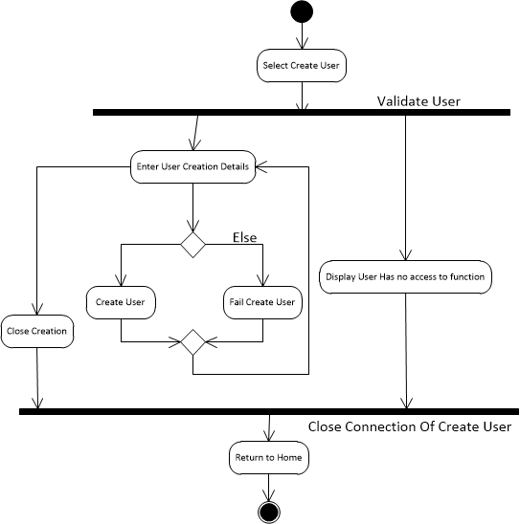

Void User(Samuel Walsh):

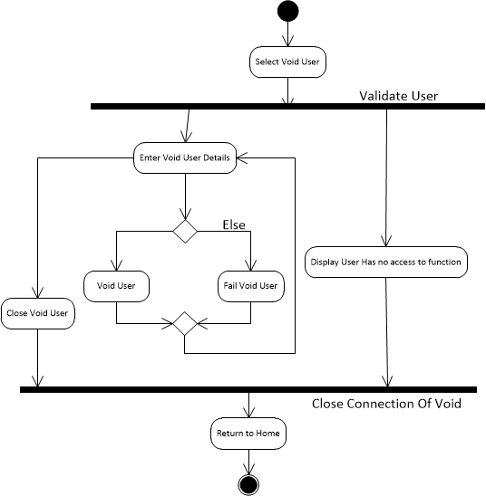

# 

# 

Generate Barcode

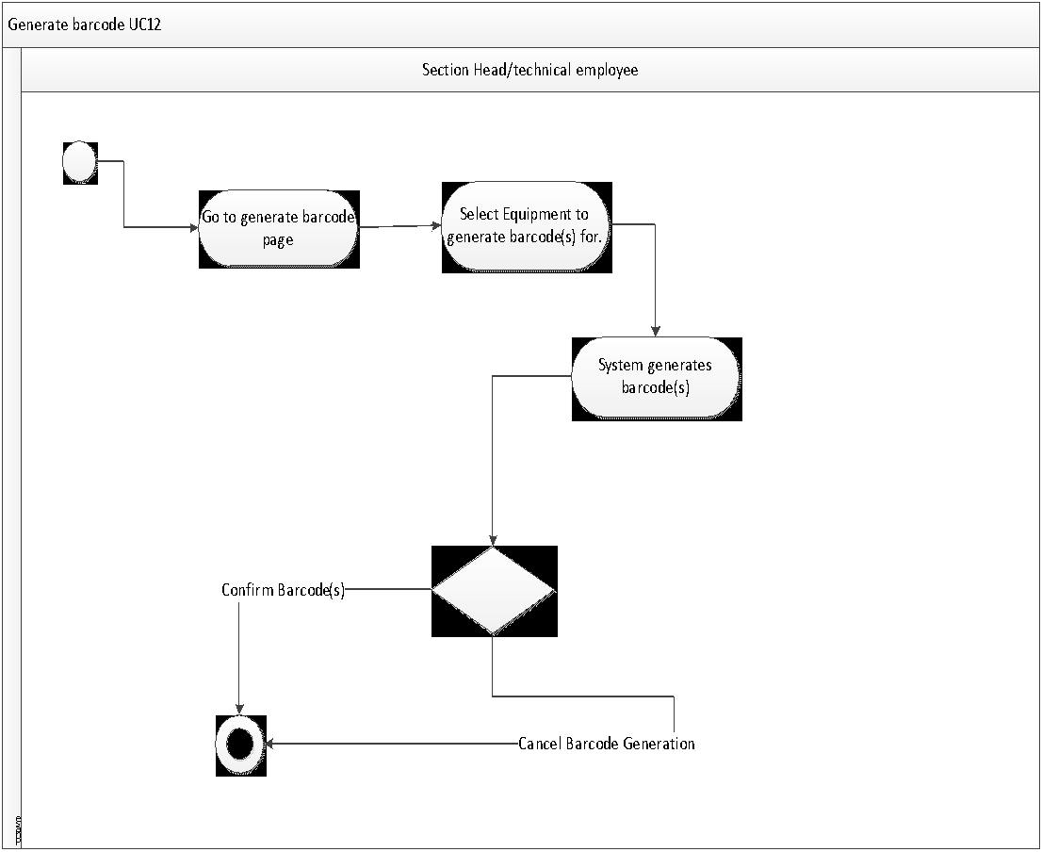

View Equipment History

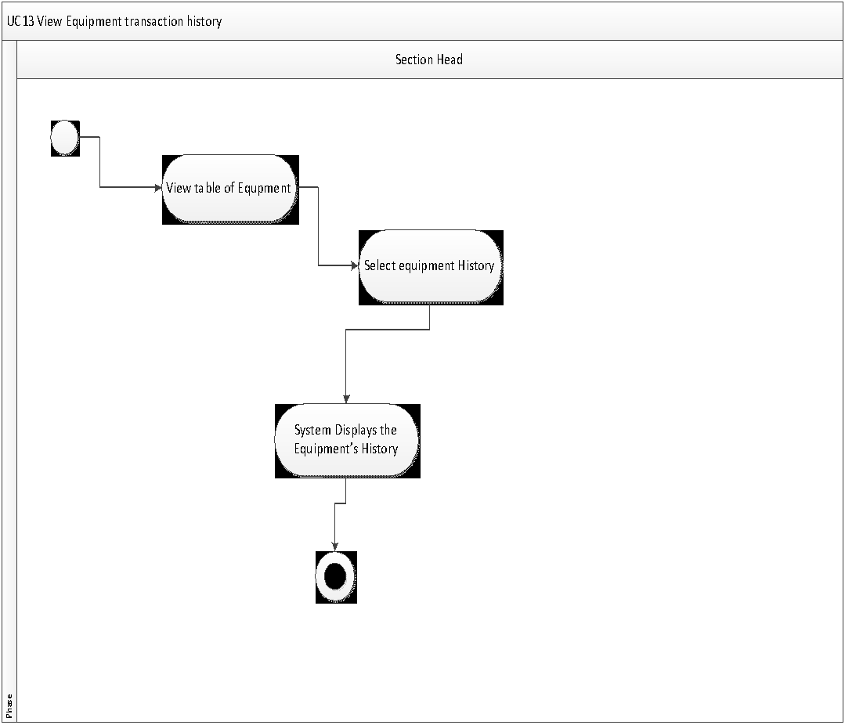

# 

# Latest Entity Relation Diagram

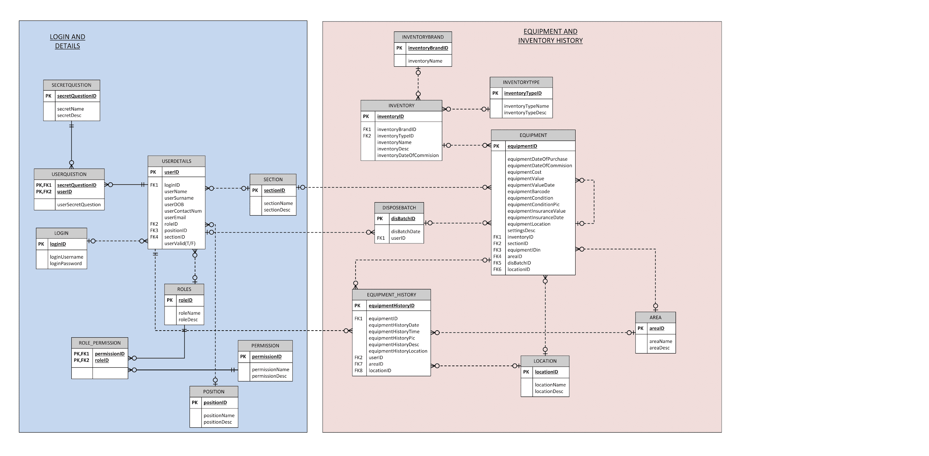

# User Interface Design

# 

Only the users who are allowed to access the system can login to use the system. In order to do so, they need to provide a username as well a password. Once the user has entered the Login button, the system will either return a true or false value. If it is true, it means the user’s login input is in the system and they will be granted access to use it. If it is false, then they just can’t enter the system. If the user forgot their password, then unfortunately they have to ask for a password reset directly at the administrator in person.

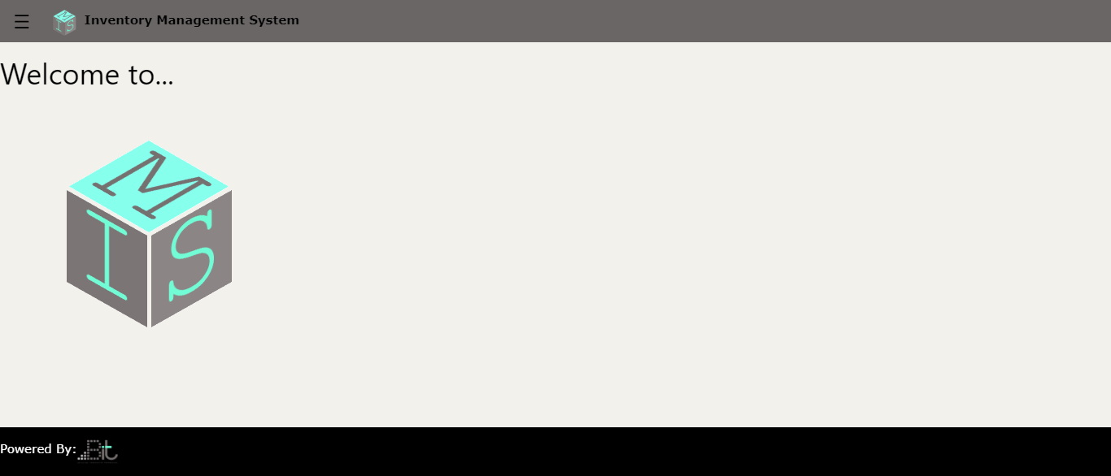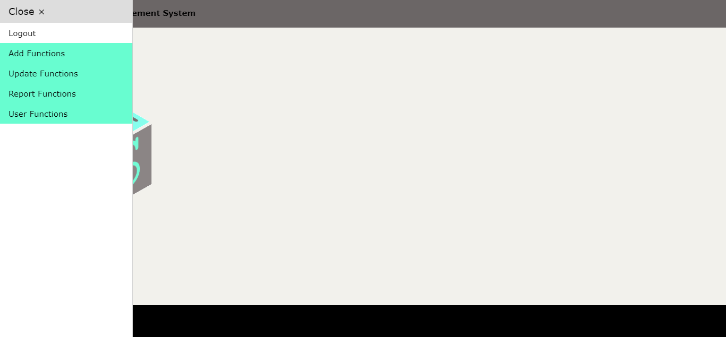

When the user has successfully entered their details, they will be allowed to implement it based on their access rights. In order to access the functions they are allowed to use, they can go on the left and press the navigation button (the button with the three stripes) and once they click it, a drop down list will appear that will display the functions.

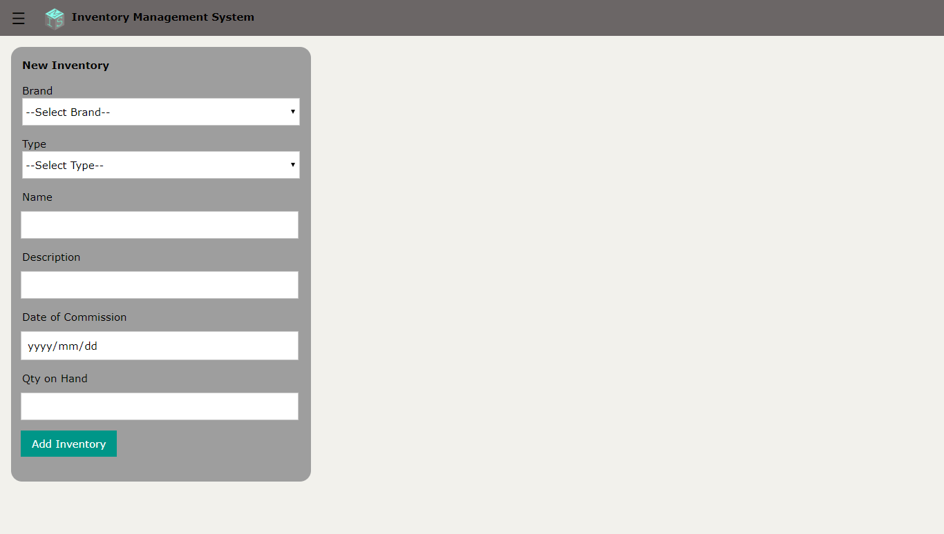

When the user requires to add a new inventory, there are a couple of compulsory requirements before they press the ‘Add Inventory’ button. It is important to give the new inventory a name, a date of commission, a brand name, and a type. The description can be optional because sometimes the description of the inventory can be exactly as that of the name. The quantity on hand is also optional because the inventory can be pre created without any stock. After the user has entered the Add Inventory button, what will get parsed through is the Brand’s ID, the Type’s ID, the name, the description (can be null), the Date of Commission, and the quantity on hand (can also be null).

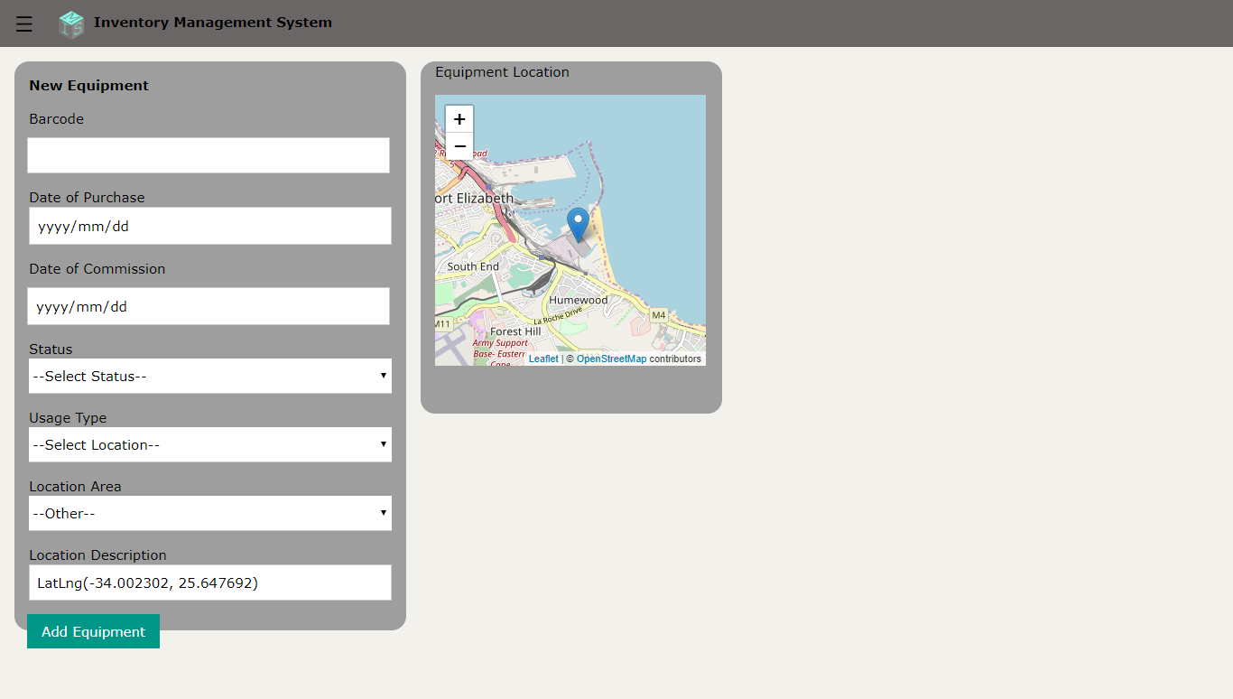

When the user wants to implement a new equipment in usage, the equipment’s barcode may either be manually entered, or it can be be scanned if their device supports that feature; date of purchase will be included, as well as they the date it became in use (date of commission). The status will either be Stable or Excellent. The Usage type can either be ‘fixed’ or ‘person’ which means that the piece of equipment can either move around remotely (like a walkie talkie for example), or it can be installed somewhere at an allocated spot. Because the System is designed for the local municipality only for now, only all the places the municipality covers will get loaded inside the Location Area dropdown. The Location Description will display the coordinates of the user’s specific location. Now when the user implements a new equipment piece, it is protocol for them to add a new piece of equipment to the system. When they do implement one to a fixed location, the user’s coordinates will get stored. However, if the equipment is in a person’s possession, we can’t unfortunately track the equipment piece’s movement every second if it is on the move.

When the presses the ‘Add Equipment’ button, the fields that cannot be a null value are all of them expect for the Location Description but only if the value of the Usage Type dropdown is set to ‘Person’.

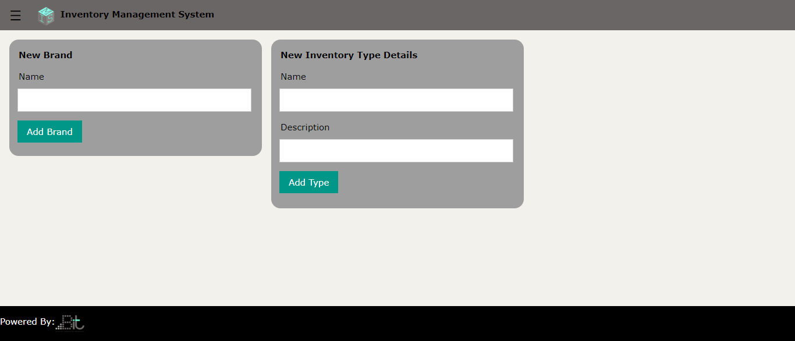

Allows a user to add a new equipment brand to the system database. The municipality may want to keep track of what an inventory’s brand is, for purchasing purposes or auditing purposes. Also makes it easier to know what equipment to replace. The user may also be allowed to add a new piece of inventory type.

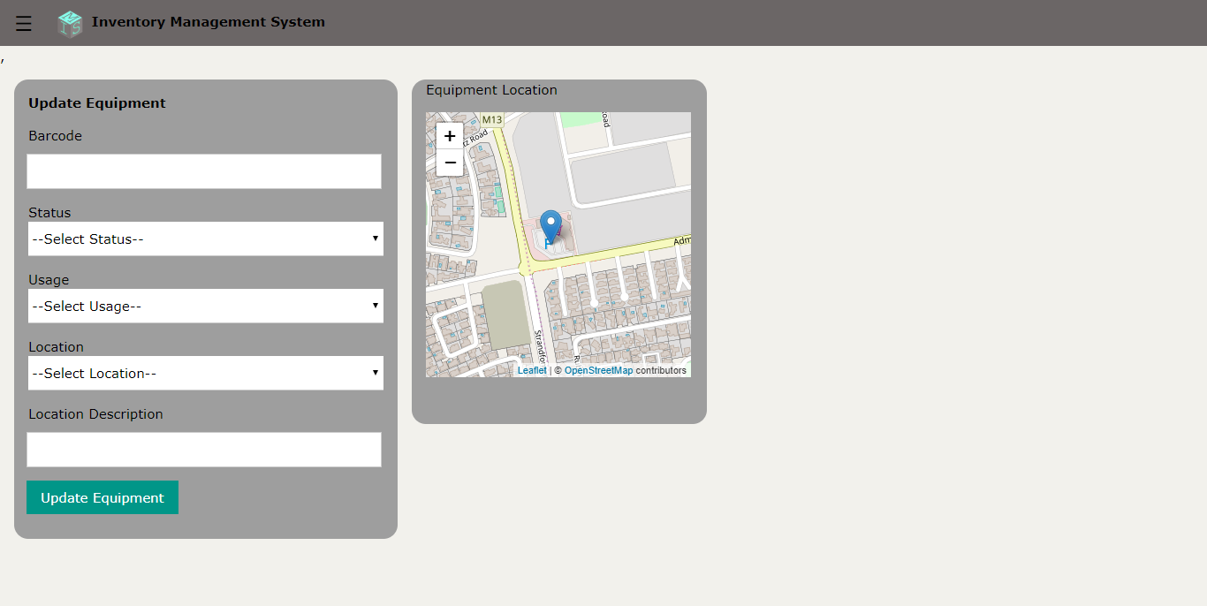

This view is used to update an equipments details. It can only be used by a section head or the technical employee. One of the most important features of this view is the ability for the to change the equipments location and to update its current status.

# Sample Reports

# 

# 

# Standards and Best Practice

For the naming convention we will be using the camelcase convention. Commenting will be done for each process to simplify the code. We will be re-using as much code as possible to reduce the workload. The stored procedures name will be prefixed with 'usp'. For GUI we will be using the standards set by the w3css style sheet which makes everything prefixed. The MVC practice will be used to keep the coding clean and separate.

# Conclusion

We really need to get our mindset straight and have proper functionality going, and a whole lot more. Before we started with this Project we had the idea that we can satisfy a 3rd Year Project’s requirements by simultaneously creating a necessary system for the local municipality. The realisation that not enough functionalities are done by a five group team can make this project a disaster and possibly fail us does hurt in a sense.

But saying that we are not quitters and we know the challenges that are facing us for Iteration 3 and probably Iteration 4 as well.

For Iteration 3 we are planning on getting the System to work flawlessly without any errors and confusions and to implement error handling, and with other undecided work to cover the workload required for a group of five. We can’t keep getting stuck with research and trial and errors. This is a team effort.